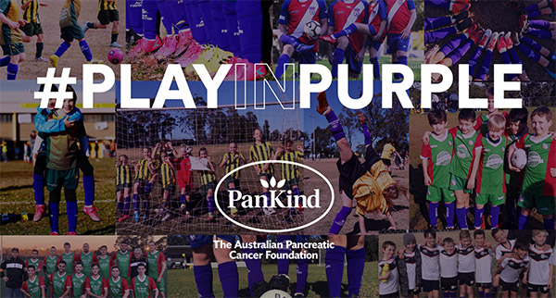

#PlayinPurple 2022
Order socks for weekends in July

This year, our club along with Football NSW and our association are proud to once again support the #PlayinPurple campaign that turns our local football fields purple for pancreatic cancer.

The #PlayinPurple weekends are embraced by players of all ages and will run on the weekends of July 23/24 & 30/31, after the school holidays. Funds raised will help be channelled into pancreatic cancer research and patient support for one of Australia’s toughest cancers.

Socks are $15 per pair, ordered online and delivered to a chosen address ahead of the #PlayinPurple weekends.

We encourage our club to participate in teams and celebrate the annual #PlayinPurple weekend for cancer research and take lots of photos, sharing on social media. The online store will be closing at the end of June so please get involved over the coming weeks.

More information & order socks: https://pankind.org.au/take-action/playinpurple/

Thank you for your support.

